

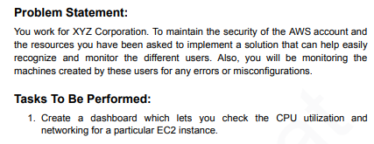

1. First We need to Create an Custom EC2-Server

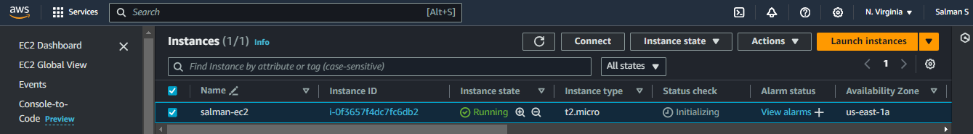

1. Go to Cloudwatch Click Create a Dashboard with I named as a EC2-Monitoring

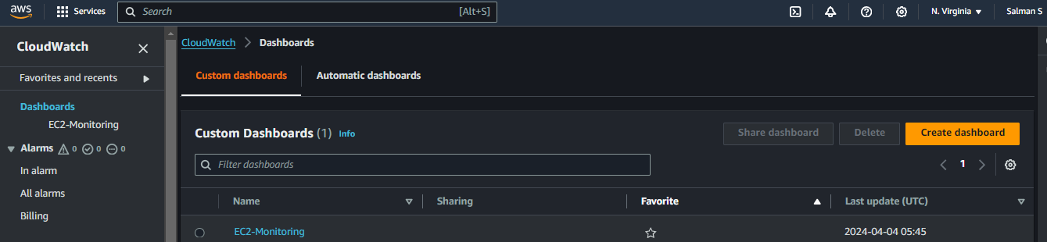

1. Click On Created Dashboard and Now Check the CPU and Networking Status For Particular Instances Before that Need to Add Widget

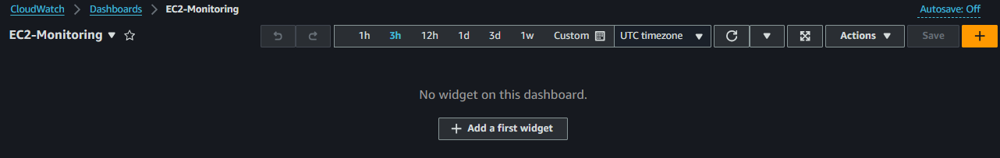

1. Select Metrics and leave it as Line and Click Next

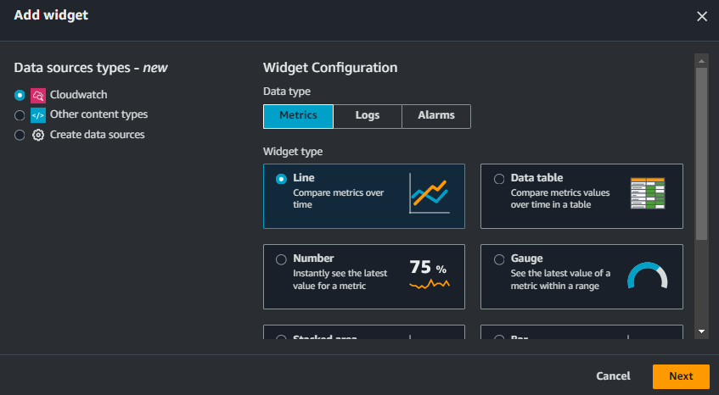

1. Now Here Select EC2

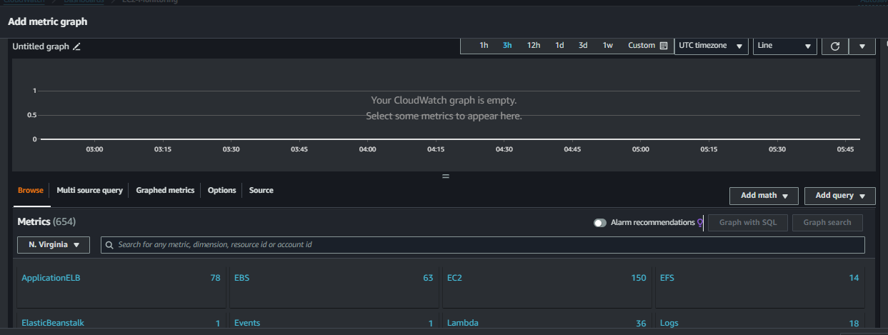

1. Click Per-Instance Metrics

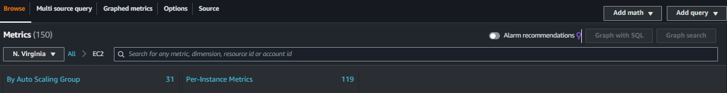

1. Filter Your EC2-Instances and Select CPU-Utilization and Networkin and Networkout and Create Widget

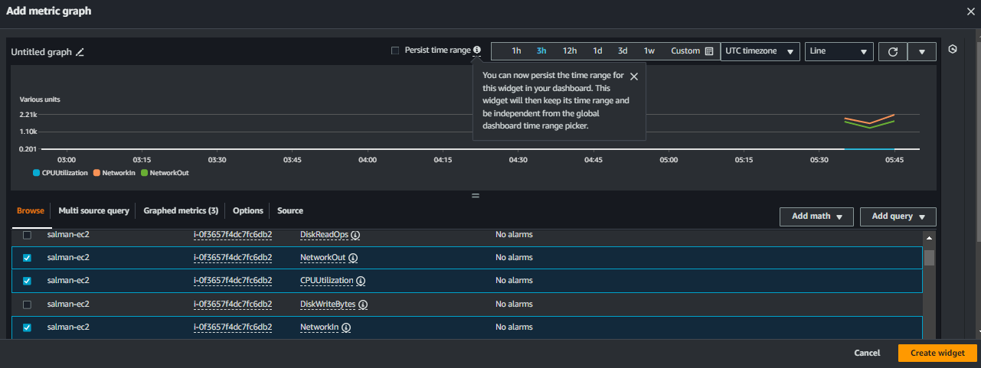

1. This is the CPU-Utilization and NetworkIn, NetworkOut Data of Selected EC2 and Click on the Chart

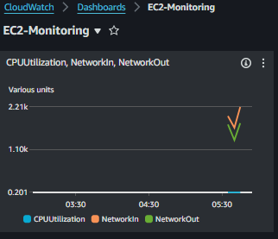

1. Click View Metrics

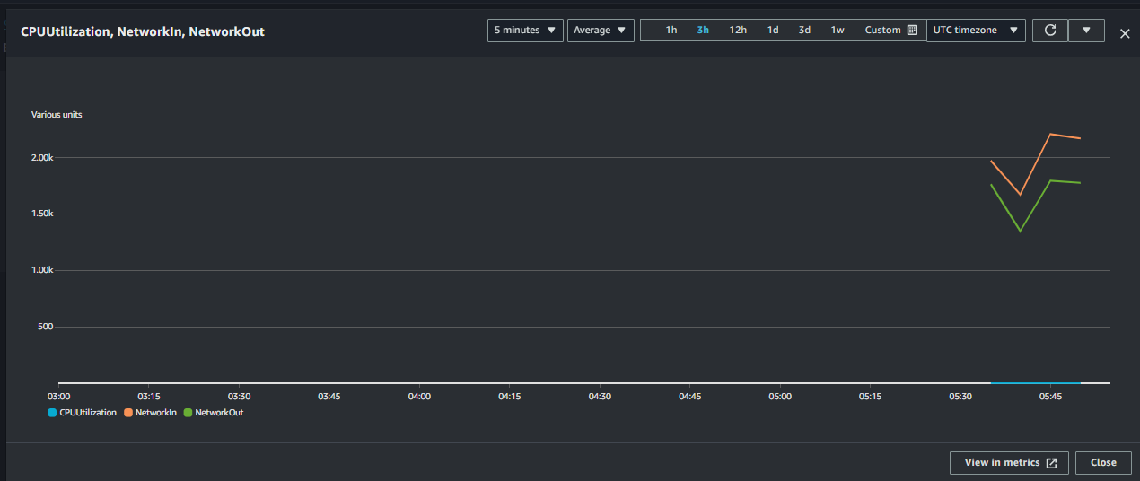

1. Here We Can Add Math and Query and We can Change Statistic and change Period Time and This is our Task Which We Completed

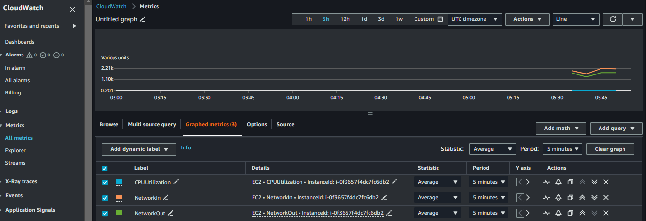

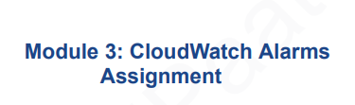

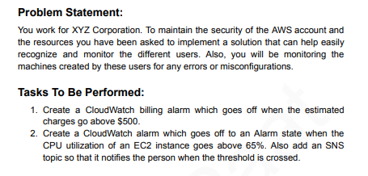

1. Create a Cloudwatch Billing Alarm Click Create Alarm

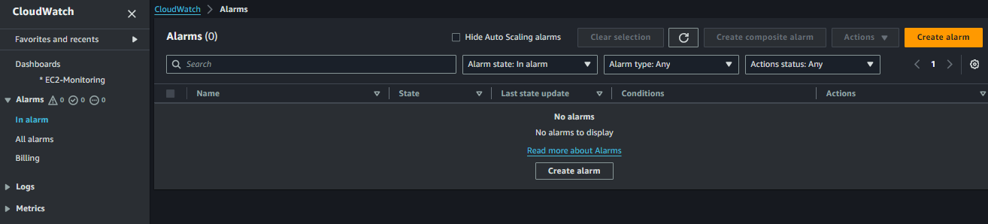

1. Select Metrics and Click Next

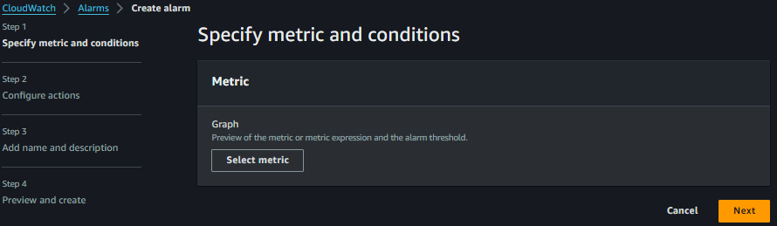

1. We are Not able to Find Billing Option So Before that we need to Billing Console

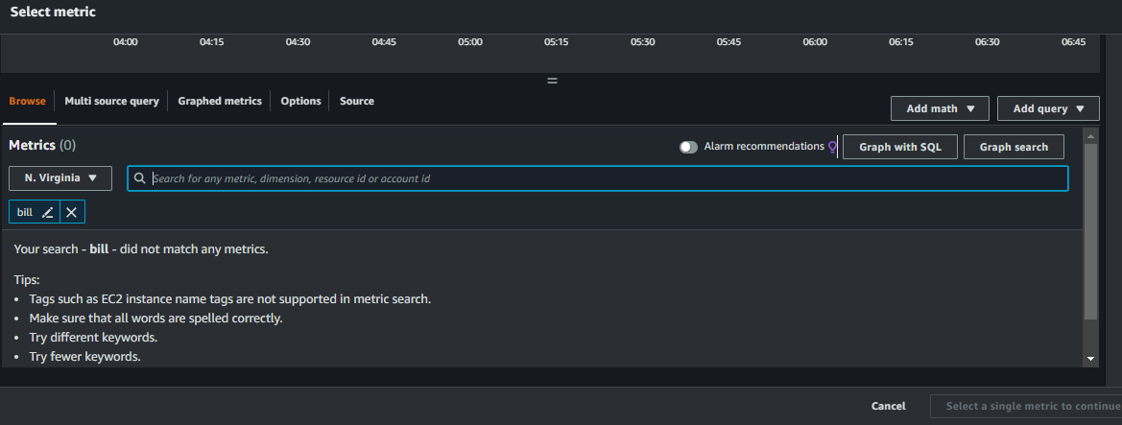

1. Go to Billing Preferences in the right Corner We will get Alert Preferences Edit it

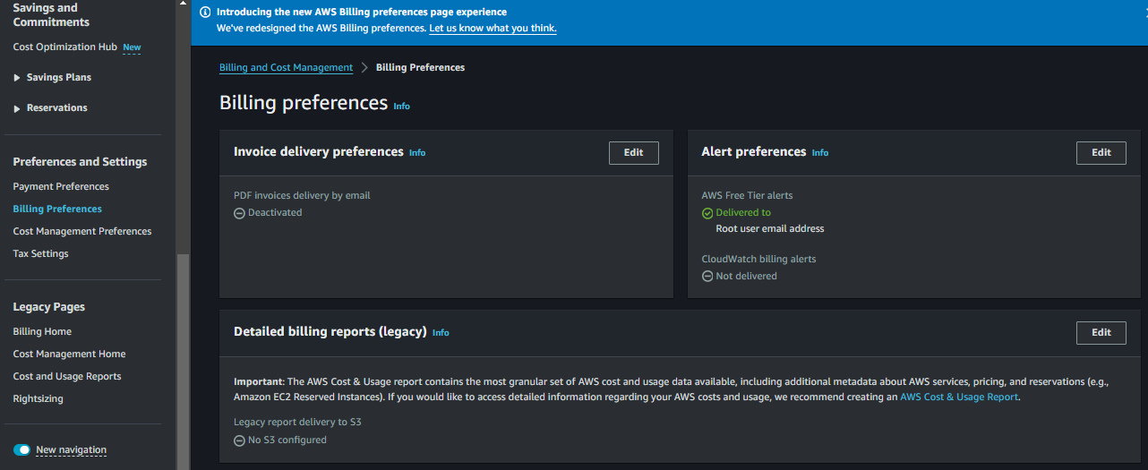

1. Select Receive Cloudwatch Billing Alerts and Update it

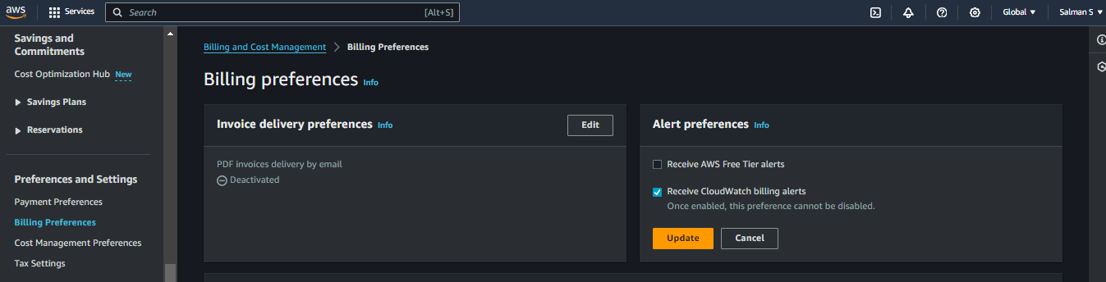

1. Now Again go to Cloudwatch Alarm and Now we able to see Billing Option Click on it

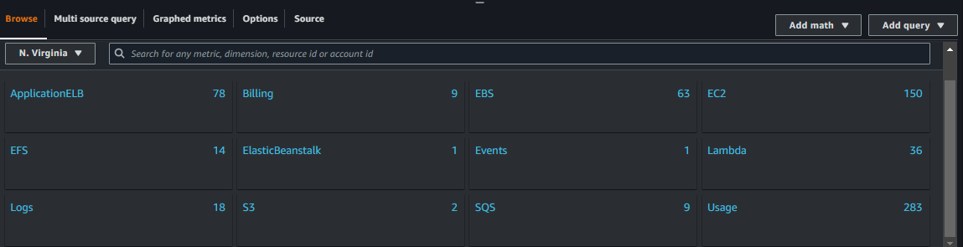

1. Selecting Cloudwatch service and Click Select Metric

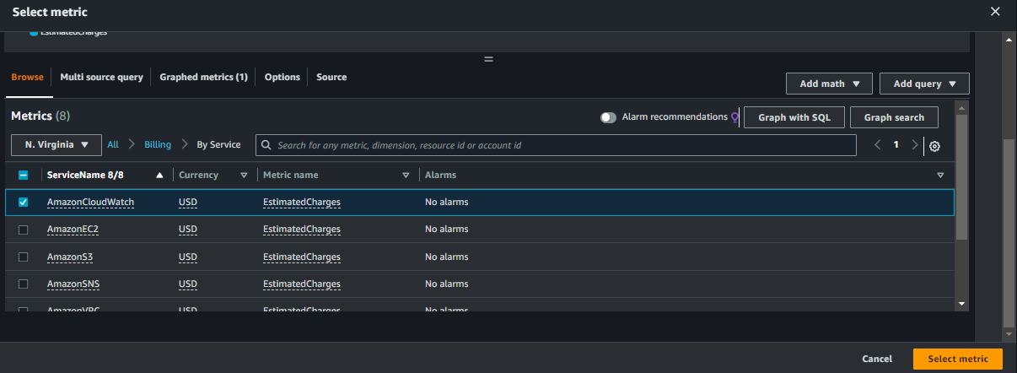

1. Estimated Charges, Now Present I leave Everything as Default but only one change 500 USD

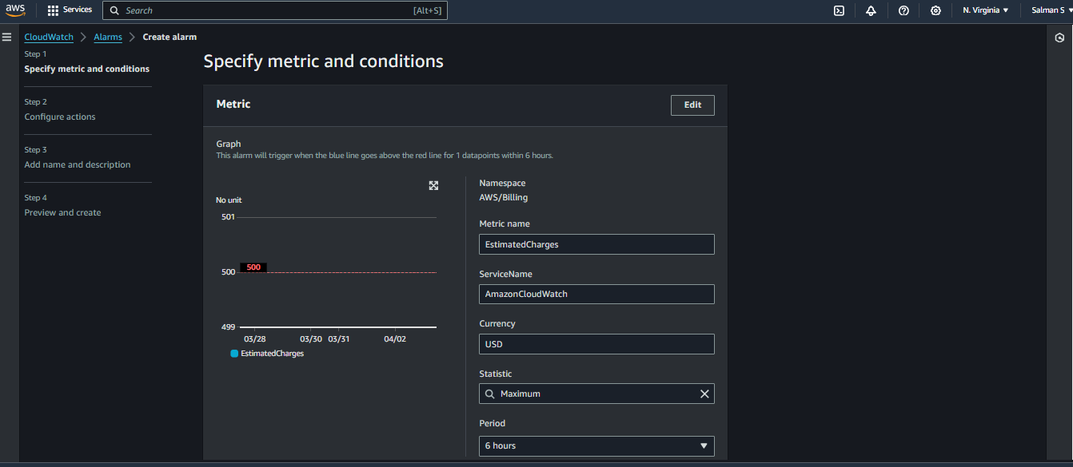

1. Selected Static and Threshold is greater than 500 USD and Click Next

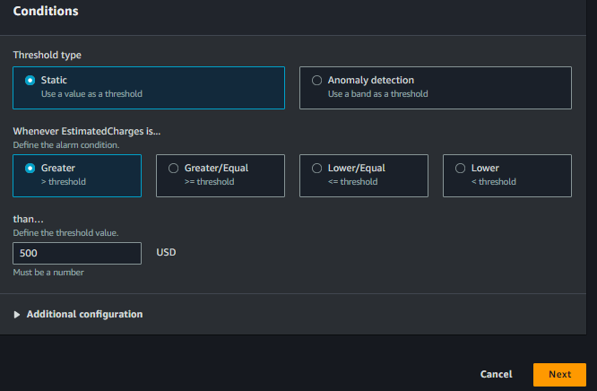

1. 2nd Step is Configure Actions Select Alarm and Here Need to Create a Topic I gave Name and Email Address

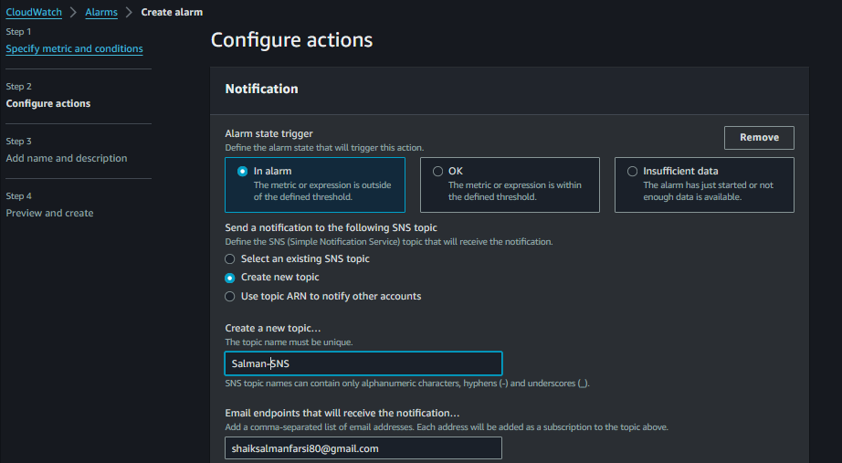

1. Leave it as Default and Next

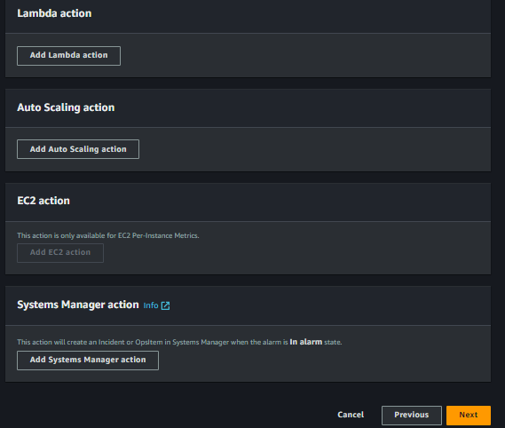

1. Triggering Error Click Create Topic

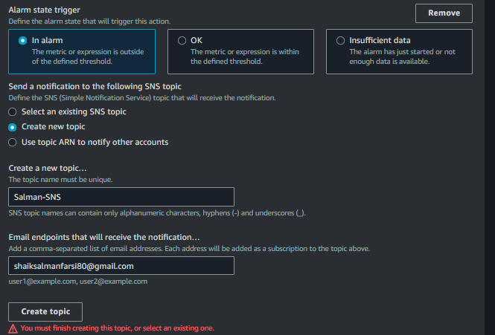

1. Give Name I gave Wrongly Because we are doing Task if More than 500 USD Usage for cloudwatch then it will trigger the Notification to Us. But I gave CPUgreaterthen65tosendSNS, But the Concept is Clear

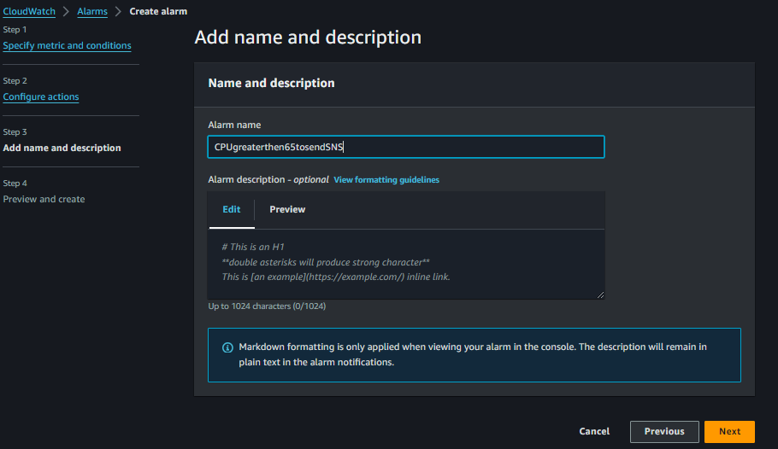

1. Preview

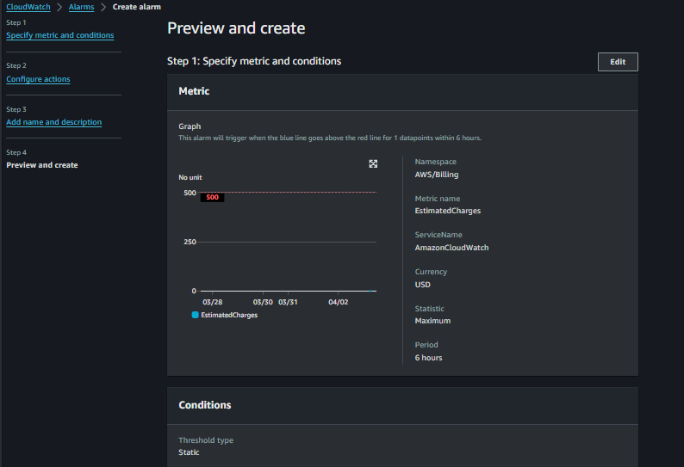

1. Preview and Click Create Alarm

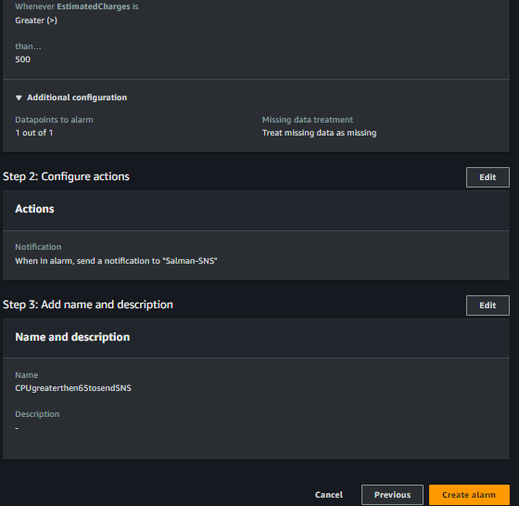

1. We Created But in the Config Part Pending Confirmation, So go Your Email which u given and Confirm It

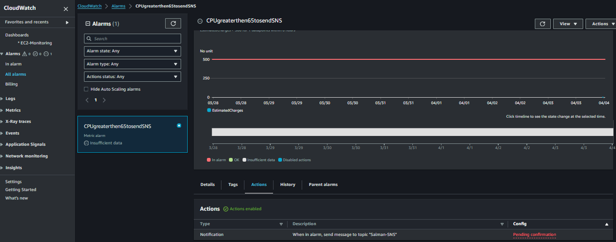

1. See I received Notification from AWS Notification Subscription Confirmation and Click Confirm

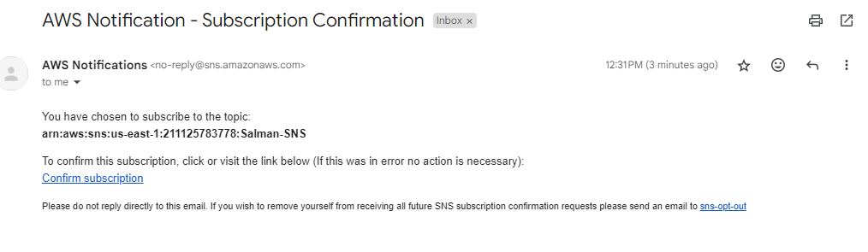

1. Now Again Go to Alarm Create another Alarm which CPU 65 greater then task have to perform

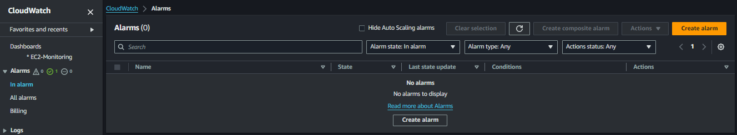

1. Select Metric and Next

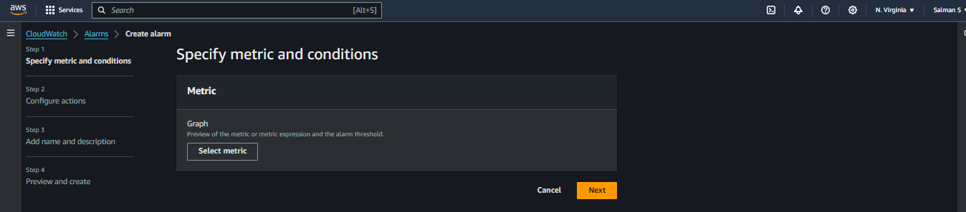

1. Select EC2

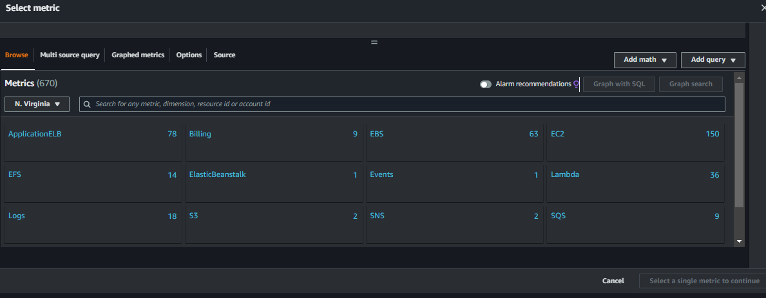

1. Select Per-Instance Metrics Because we are not creating to Autoscaling only Particular Instances so Click it.

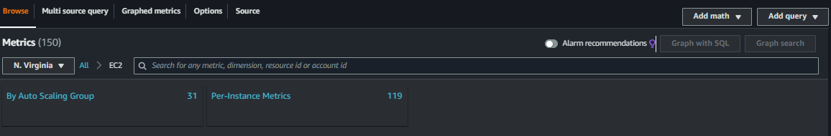

1. Select CPU-Utilization According to Task

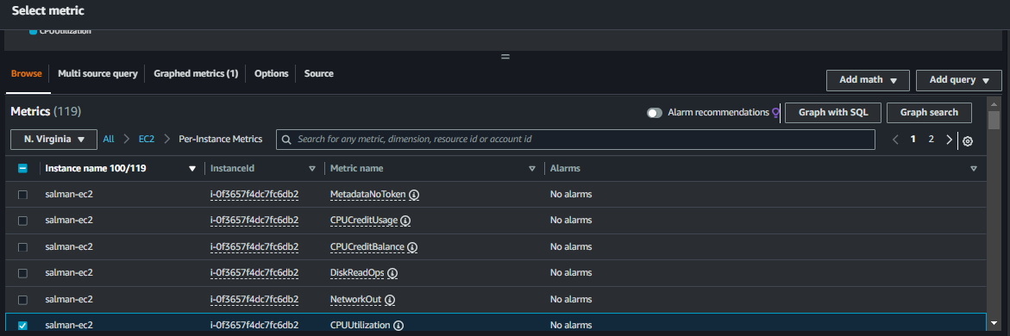

1. Leave it as a Default

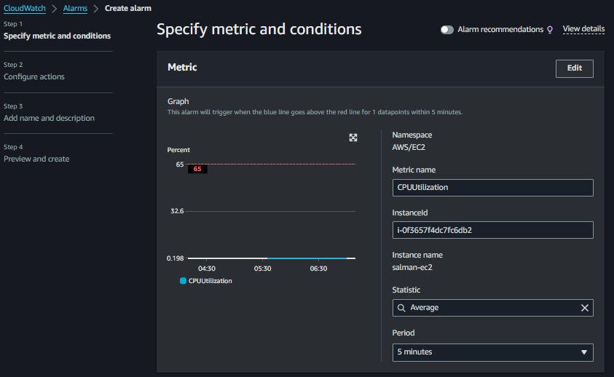

1. Selected Static and Selected Greater than 65 and Click Next

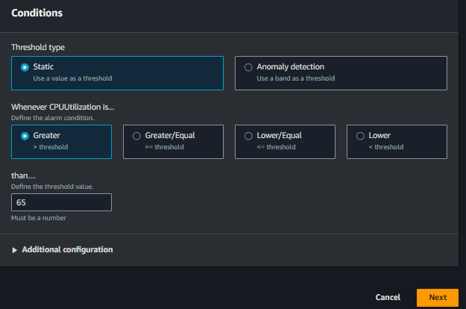

1. Select In alarm and Selected SNS According to our Task for Future Notification Receive

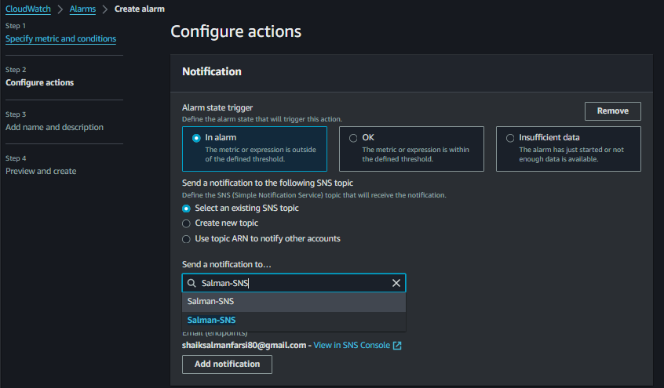

1. Here I Selected Terminate Instance No need according to Task But Once it will cross 65% CPU Utilization then it will going to Terminate, Generally No Need to terminate Better we will stop Instance is Better and also we Receive Notification According to Our Configuration

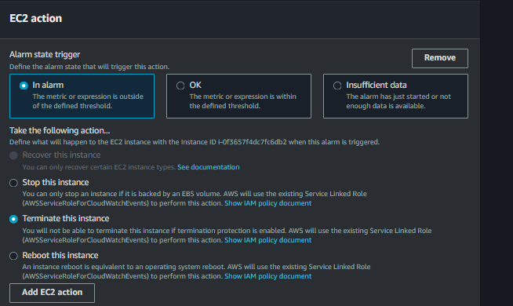

1. Give Alarm Name and Next

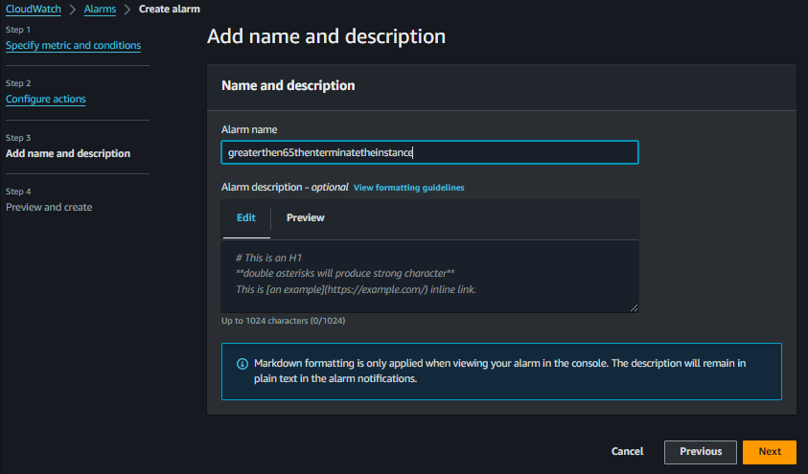

1. Preview

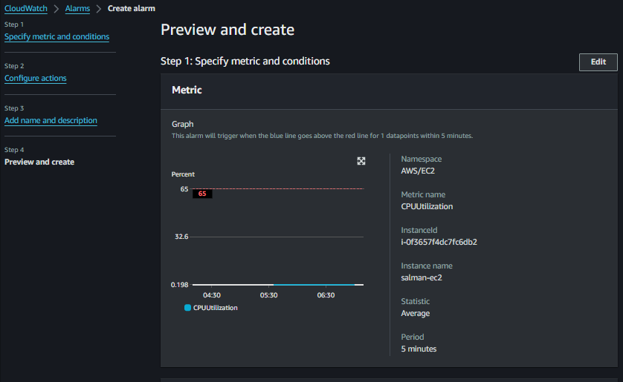

1. This are Actions for CPU-Utilization which we configured Send Message and Terminate Alarm

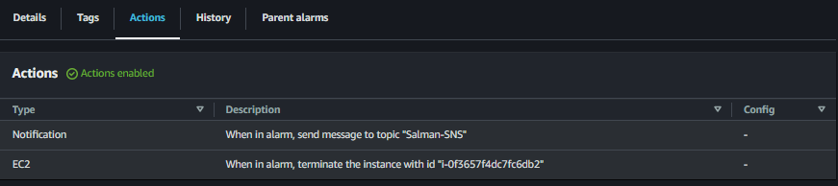

1. These 2 Alarms Which we Created

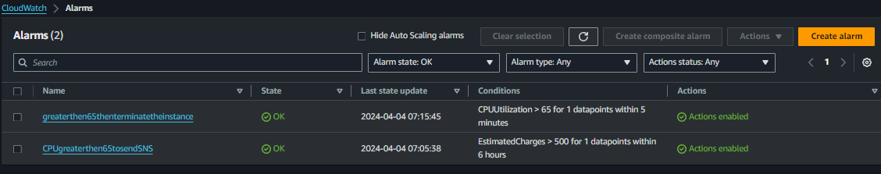

1. And This is Billing alarm, So This is the Task Which given in the Assignment.

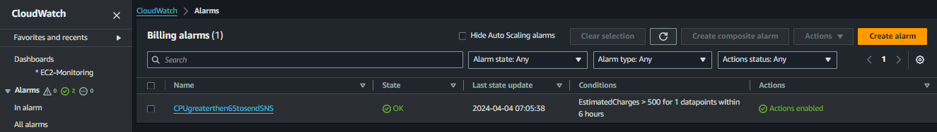

Thank You